GENERAL INSTRUCTIONS OF FIRE – Résidence Albin Peyron
60, Rue des Frères Flavien – 75020 PARIS Tél: 01.48.97.54.50.

PREVENTION

Smoking is prohibited in all rooms equipped with fire detection
It is forbidden to neutralize fire detectors
Do not block the accesses of the areas of help
Know their location and their functionning
Leave clearances and exits free
Do not obstruct the closing of fire doors
Do not block the fire doors in the open position

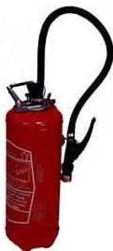
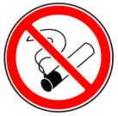


FIRE
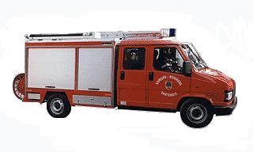
FIREMEN : 18 or 112 (mobile phone)
Call the Reception : 01 48 97 54 50

From the discovery of a disaster, keep calm
Activate the alarm (press the closest alarm box)
Attack the fire with the fire extinguisher without taking risks
In case of smoke fall you, the fresh air is near the ground



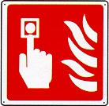
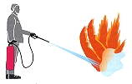


EVACUATION




From the hearing of the sound signal or in order :
Keep calm
Follow the instructions of the guide of evacuation
Evacuate without precipitation by closing windows and doors behind you
Do not use elevators
Follow the evacuation markup 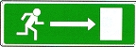

Never go back except by order of the evacuation guide

Go to the assembly area defined for your building

